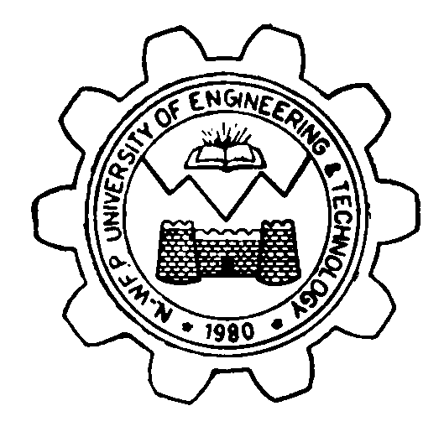 | UNIVERSITY OF ENGINEERING & TECHNOLOGY, PESHAWAR  DEPARTMENT OF MECHANICAL ENGINEERING  Phone: 92-91-9222217 Fax: 92-91-9216663  Email:chairmech@uetpeshawar.edu.pk

Ref. No. Dated: / / .

To
General Manger,
OGDCL, Islamabad

Subject: Internship of Mechanical Engineering Student

It is stated that, practical training of the engineering student is pre-requisite for the award of B.Sc. degree in Mechanical Engineering, at UET Peshawar.

I shall be very obliged if you can please cooperate with the educational policy of University of Engineering and Technology, Peshawar and assist us by accepting the following student as apprentice for the practical training (internship) in your industry/organization. The student will abide by your organization rules and regulations. The particulars of the applicant student are as follow;

Student’s Name: ______________________________________
Father’s Name: _______________________________________
Semester: _______________________________________
Registration No: _______________________________________
Phone No: _______________________________________

Furthermore, it will be of an utmost kindness if the student may please be paid an honorarium/stipend. After completion of the internship, please return the evaluation form (copy attached) to the internee or send it directly to the undersigned and issue an internship certificate to the student.
.

Incharge Career Resource Center, MED
Address: Department of Mechanical Engineering
UET Peshawar, University Road Peshawar, KP
Email: shakoor@uetpeshawar.edu.pk
Phone No: 0345-5646565

